Project Concept Paper

For

2022 Korea ICT Leadership Program

Contents

- Program Overview 3

- Program Details 4
- Program Contents 4
- Program Schedule 5

Ⅲ. General Information 6
- Support 6
- Accommodation & Facilities 7

Ⅳ. Application 8
- Qualification Requirements 8
- Application Process 8
- Application Form 9

Ⅰ. Program Overview

◈ Introduction

Korea ICT Leadership Program (KoIL) invites policy-makers to share the ideas on ICT policy and technology and establish a close network between Korea and the partner country to address challenges on public services through ICT.

◈ Program Objectives

The KoIL Program is designed to strengthen international cooperation and contribute to national informatization of partner countries by providing meetings with public officials and ICT companies in Korea, and planning joint-project with NIA to enhance the ICT policy implementation capacity of policy-makers and improve public services with ICT.

- Expand international cooperation in the ICT field with Korea

- Deepen insight on ICT policies and emerging technologies

- Promote digital transformation by sharing the Korean best practices

◈ Program Description

- Duration

- August 1, 2022 ~ October 31, 2022 (3 Months)

- Location

- Korea

- Language

- English

- Number of participants

- 4 Government officials

- Qualification Requirements

- Should be a government official in director level or below of the ministry in charge of ICT

- At least 5 years of working experience in ICT department.

- NIA will cover all expenses including flight fee, accommodation, insurance and daily, travel expenses for participants.
Ⅱ. Program Details

◈ Program Contents

◦ Participants’ Duty

- Joint Project

- NIA and the participants are going to plan the new project to address challenges and improve public services of partner countries with ICT.

- NIA and the participants will make the project concept paper for the new project and proposal for project approval by the Korean Government

- Country & Technology Analysis

- Participants will make reports on ICT policy status and strategies in their countries and plans for application of the emerging technologies to their countries.

- Knowledge Sharing

- Participants will share their ideas on ICT policies and emerging technologies and discuss with NIA staff.

◦ Opportunity for the participants

- Business Meeting

- Participants will have a 1:1 meeting with the Korean ICT companies to establish and discuss plans to import the emerging technologies to their countries

- Study Visit

- Participants will visit to the ICT institutions in Korea to experience the up-to-date technologies and services.

- ICT Seminar

- Korean ICT experts will introduce Korean ICT services, policies, emerging technologies and their application cases.

- Participants will discuss the strategies for national informatization of their countries with the ICT experts from Korea and International organizations.
◈ Program Schedule

- August 1st - 31st

Week | Events | Venue
Week 1 | Orientation | Jeju, Korea
Week 2 | Knowledge Sharing on ICT Policies and Technologies
Week 3
Week 4 | Study visit to Korean ICT institutions | Seoul, Korea
Week 5 | ICT Seminar

- September 1st – 30th

Week | Events | Venue
Week 1 | Country Analysis & Discussion | Jeju, Korea
Week 2
Week 3 | Country Analysis Sharing | Seoul, Korea
Week 4 | Technology Analysis | Jeju, Korea
Week 5 | Technology Analysis Sharing | Seoul, Korea

- October 1st – 31st

Week | Events | Venue
Week 1 | Business Meeting with Korean ICT Companies | Seoul, Korea
Week 2 | Plan the joint-project and make Project Concept Paper | Jeju, Korea
Week 3
Week 4
Week 5 | Project Concept Paper Sharing | Seoul, Korea

- The schedule of the program is subject to change

Ⅲ. General Information

◈ Support

Classification | Contents
Accommodation | NIA Global Center (Jeju, Korea)
Office | Global Cooperation Department, NIA
Travel Expenses (International) | Flight fare (Round-trip), Baggage charge
Travel Expenses (Domestic) | Flight fare, Lodging, Transportation
Daily Expense | $30 a day (cash)
Insurance | Travel, Casualty, Health

- The coordinator will be assigned to NIA Global Center to help the adjusting to living in Korea and daily lives of the participants

◈ Culture experience

NIA will provide opportunities for participants to experience the Korean culture.

- Seoul

Venue | Contents
Gyeongbokgung Palace | Experience the traditional royal palace
Namsan Tower | Enjoy the night view of the Seoul city

- Jeju

Venue | Contents
Mt. Halla | Climb Mt. Halla and enjoy the landscape of Jeju island
Seongsan Ilchulbong | Climb the tuff cone and watch the sunrise
Traditional Market | Experience Korean traditional goods and buy souvenirs

◈ Accommodation

- NIA Global Center

Participants of KoIL live in NIA Global Center in Jeju, Korea. One participant will be assigned to each room.

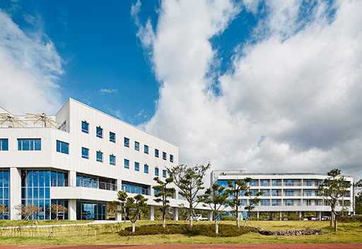
Figure 1. NIA Global Center

- Accommodation Facilities in NIA Global Center

Room Facilities | bed (1)-Super single size, desk(1), chair(1), wardrobes(1), TV(1), air conditioner, toilet, shower booth, Hair Drier, Towel, Bedding (blanket, pillow), Toiletries
Public Facilities | Gym, Lounge, Seminar Room (3), Water Purifier, Microwave, Cafeteria, Front loader, Clothes dryer

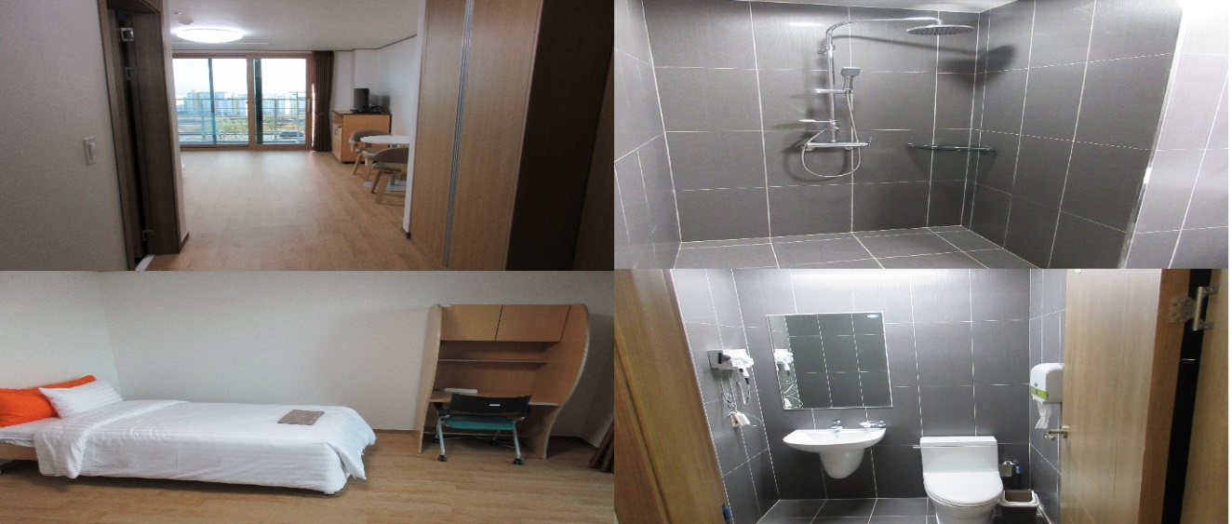
Figure 2. Room Facilities
Ⅳ. Application

◈ Qualification Requirements

- Should be a government official in director level or below of the ministry or agency in charge of ICT

- At least 5 years of working experience in ICT policy implementation or planning the projects for national informatization.

- Be able to communicate with others and write the reports in English

- Do not have any identity issues for working and staying in Korea

◈ Application Process

Please submit the Application Form and an Official Letter with the authorized signature and seal through the Embassy of Republic of Korea in your country, Ministry of Foreign Affairs and Ministry of Science and ICT of the Republic of Korea, and National Information Society Agency by end of January, 2021.
After the application period, the MSIT and NIA will review the submitted proposals and conduct a feasibility study in the partner country. Based on the results of the feasibility study, the MSIT and NIA will inform the finalized partner country via an official letter.

For additional information regarding the project, please contact jsim@nia.or.kr.

Application Form

for the Korea ICT Leadership Program

- Type in English and print out, hand-writing is not acceptable

Section I. Participant’s information

Basic Information
Name of Country
Ministry
in charge of ODA
Name |  | Ministry/Organization
Department/Division |  | Position
Duties/Responsibilities
Work E-Mail |  | Personal E-Mail
Telephone Number |  | Mobile Number

Section II. Qualification

English Proficiency
Listening | ☐Excellent ☐Fair ☐Poor | Speaking | ☐Excellent ☐Fair ☐Poor
Writing | ☐Excellent ☐Fair ☐Poor | Reading | ☐Excellent ☐Fair ☐Poor
Mother  Tongue |  | Other  Language(s)

As English is the official language used for the project, participant’s English proficiency is an important determinant for application approval.

Professional Background (list 3 most previous positions)
Year(from/to) | Organization | Position | Responsibilities
/
/
/

Educational Background (list 3 most previous educations)
Institution | City/Country | Subject | Degree/Year Earned
 | / |  | /
 | / |  | /
 | / |  | /

Section III. Interest Survey

1. Describe your country’s policy priorities in the field of ICT.
○ Describe in detail the national priorities and policies related to the development of ICT and what your organization is doing to achieved those goals

2. Describe the specific area of public services that your government is interested in.
○ State the certain areas of public services that your government want to improve through ICT.
(Transportation, Manufacturing, Health, Education, Tourism, Agriculture, Finance, etc.)

3. Describe the technologies in the ICT field that you are interested in.
○ State the technologies that you are interested in.
(AI, Bigdata, IoT, Cloud computing, 5G, Blockchain, Cybersecurity, Smart city, etc.)

4. Describe the projects you are currently cooperating or planning to cooperate with Korean agencies or companies
○ State the title of the projects and the name of the institutes
○ Describe the sub-tasks and the goals of the projects.

Section IV. Program Plan

1. Describe your achievements or outcomes related to National Informatization.
○ Describe what you did and the results in your working experience trying to improve public services with ICT.
○Describe your specialty area in the ICT field.

2. Describe your plan during the work in Korea
○ Describe the work plan in Korea to contribute national informatization of your country.
○ Describe the strategies to connect the KoIL with other ICT projects of your country.
○ Describe the follow-up plan to manage the cooperation between the Korea and your country.

3. Describe the performance goal and expected benefits of the program.
○ Describe the goals that you and your agencies can achieve through the KoIL program.
○ Describe the expected benefits that will be achieved through the KoIL program.

This report is prepared by:
Name |  | Position
Department |  | Telephone number
Fax number |  | Email
☐ I confirm that I have read and understood the project overview thoroughly and the information given in this concept paper is true, complete and accurate.

(signature)
(Name of the signee)
DD/MM/YYYY

